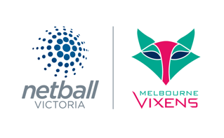
Netball Victoria All Abilities Netball Schools Carnival
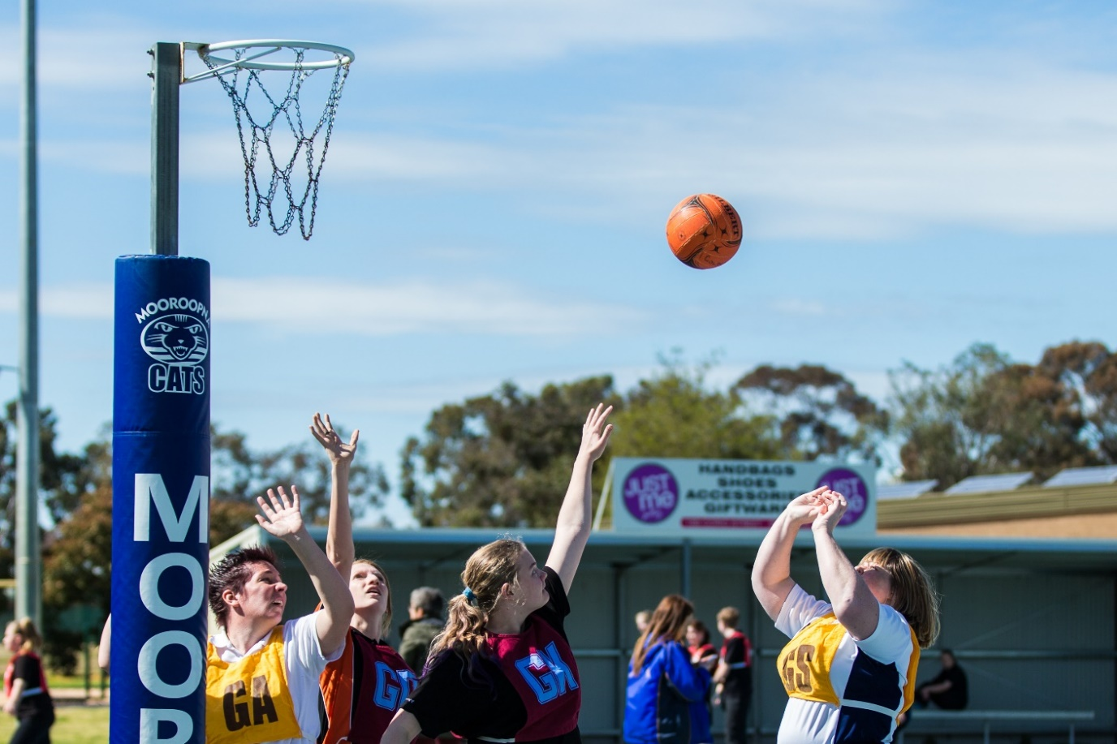
REGISTRATIONS NOW OPEN!
2021 Dates & Venues:
Date / Time | Venue | Address
Tuesday 27th July | Kelly Park | Dalgleish Street  Wodonga
Thursday 12th August | Monash Reserve | Monash Road  Newborough
Thursday 19th August | Knox Regional Netball Centre | Dempster Street  Ferntree Gully
Wednesday 25th August | Warrnambool Stadium | Caramut Road  Warrnambool

What is the Netball All Abilities Schools Carnival?
- One day round-robin lightning premiership for Specialist and Special
Development Schools
- Umpires provided
- Competition focused on maximum Participation and Inclusion
- Beginners welcome
- Female, Male and Mixed Divisions (final divisions TBC depending on demand)
- Opportunity to have a game-sense program (min. 3-4 sessions) conducted in-school by Netball Victoria community coaches and/or delivery partners leading up to a Carnival

Eligibility
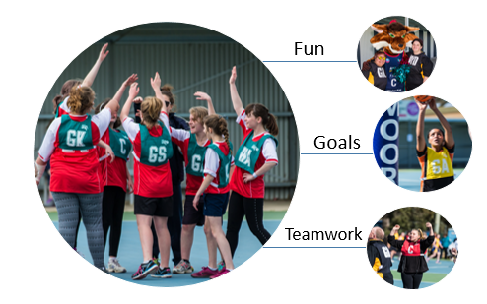
- Year 7-12 students
Special Development Schools
- Year 7-12 students
Specialist Schools
- Schools with at least 70% of multi-class students

Cost
- From $70 per School (refer to Packages Available)
- Funding available to schools through Sporting Schools

Packages Available
Package | Cost | Early Bird | Team Entry | Equipment | Coach | Funding available? | Application Dates
1 | $70 | $50  (If registered one Month prior to relevant competition date) | Yes | No | No | Yes through Sporting Schools | 1st May – 27th June
2 | $350 | $150  (If registered one Month prior to relevant competition date) | Yes | Yes | Yes | Yes through Sporting Schools | 1st May – 27th June
Please Apply Here for Sporting Schools funding
**REGISTER NOW – PLACES LIMITED**
Contact:
To find out more about how to enter, eligibility and program benefits, please contact:
E: community@netballvic.com.au
P: 9321 2222
Netball Victoria All Abilities Schools Carnival Supported by:

Netball Victoria All Abilities Schools Carnival – Available Packages

 | Package 1:  Schools Carnival Only | Package 2:  Schools Carnival  + Clinic  (Coach Provided)
Program Description | - Schools compete in the Netball Victoria All Abilities Netball Schools Carnival.  - Teams of 7 – 12 players can be entered.  - Female, Male and Mixed Divisions (final divisions TBC depending on demand) | As per Package 1 plus:  - Coach or SEDA delivered introductory program (maximum 1:15 coach to student ratio; a teacher MUST also be present)  - 4 sessions = 1 program  - Sessions are between 40 to 60 minutes and can be conducted in-school or after-school time  - Extra sessions may be requested at $60 per session  - Coach provision is subject to availability
Cost | $70  - $50 if entered by one month prior to relevant competition date  (regardless of number of teams entered) | $350  - $150 if entered by one month prior to relevant competition date  (regardless of number of teams entered)
Timeframe | One-day carnival in July / August | One-day carnival in July / August  - 4 sessions to be delivered in school time by teacher/volunteer in the lead up to the Carnival

Netball Victoria All Abilities Netball Schools Carnival – Available Packages

 | Package 1:  Schools Carnival Only | Package 2:  Schools Carnival  + Clinic  (Coach Provided)
School Benefits | - Entry into an All Abilities Netball Carnival | - Entry into All Abilities Netball Carnival  - Equipment Kit
Coach Provided? | No | Yes
Equipment Provided? | No | Yes
Giveaway to Students? | - Certificate of participation  - Melbourne Vixens spot prizes at the carnival | - Certificate of participation  - Melbourne Vixens spot prizes at the carnival
How to Register | To Netball Victoria directly | To Netball Victoria directly
Registration Timeframe | 1st May to two weeks prior to relevant competition date | 1st May to two weeks prior to relevant competition date

** Schools that register for these Packages MUST commit to entering at least ONE team in an All Abilities Schools Carnival **

Please complete the below form, ensuring information is as accurate as possible before returning it to Netball Victoria.
Please allow three (3) weeks from the receipt of your registration for the delivery of items.

Page 1 of 2
School Details
School Name:
Contact Person:
Postal Address:
(for correspondence)
Phone: | ( ) |  | Mobile:

E-mail:

Program Details
Package Type  (Please tick/highlight) | Package 1 (Schools Carnival Only) - $70 ($50 if one month prior to relevant competition)  Package 2 (Schools Carnival + Coach delivered Clinic) - $350 ($150 if one month prior to relevant competition)
Schools Carnival Details  (Which carnival is your school participating in?) | - Wodonga, Tuesday 27th July, 10:00am – 2:00pm  Moe, Thursday 12th August, 10:00am – 2:00pm  Knox, Friday 19th August, 10:00am – 2:00pm  Warrnambool, Wednesday 25th August, 10:00am – 2:00pm
Teams Entered  (Each team consists of 7 to 12 players and MUST be managed by a teacher/aide/volunteer) | Secondary (Years 7-12) Girls (no. of teams: _____________)  Secondary (Years 7-12) Boys (no. of teams: _____________)  Secondary (Years 7-12) Mixed* (no. of teams:______________)  *Mixed teams consist of maximum 3 boys on court at any one time; no more than one boy in each goal circle  Team Categories are dependent on number of registrations and not all divisions may be offered
Coach-delivered Program Start Date  (Package 2 only) | Preference 1: _________________________________________________  Preference 2: _________________________________________________  Preference 3: _________________________________________________
Program Day  & Time  (e.g. Mondays, 12:30pm – 1:30pm | Preference 1: ___________________________________________________________  Preference 2: ___________________________________________________________  Preference 3: ___________________________________________________________
Do you give permission for the Netball Victoria to provide your details to a local NetSetGO  Centre/Netball Association to make contact to help your participants join a local club/association? |  |  |  |  |  | Yes |  |  | No
Equipment Distribution
Delivery Address:
(MUST not be a PO Box as delivery needs to be signed for)
Suburb: |  |  |  | Postcode:
Delivery Instructions:
Participant Information
(Please provide accurate numbers to ensure correct allocation of participant items are delivered)
Total number of participants: |  | Total number of female participants: |  |  |  |  |  | Total number of male participants:

Netball Victoria
PO BOX 60 North Melbourne VIC 3051
PH: 9321 2222
F: 9321 2233
E: community@netballvic.com.au

OFFICE USE ONLY

Date Received:
Received By:
Actions | - Package 2 submit Clinic form  - Contact School to confirm Program Details (dates, times, classes)  - Assign Coach to Program  - Confirm Booking with School  - Invoice School  - Pay Coach  - Liaise with School re. Schools Carnival final details and requirements
Page 2 of 2

