Follow these few quick steps to get started on creating your new website.

Step 1: Create your new Wix website account. Go to www.wix.com and click Get Started

Step 2: Enter your email and a password and
Click Sign Up. Step 3: Select Skip
(bottom right of the page)
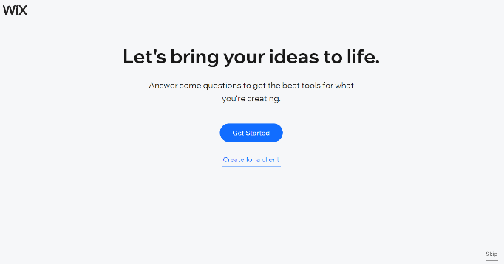
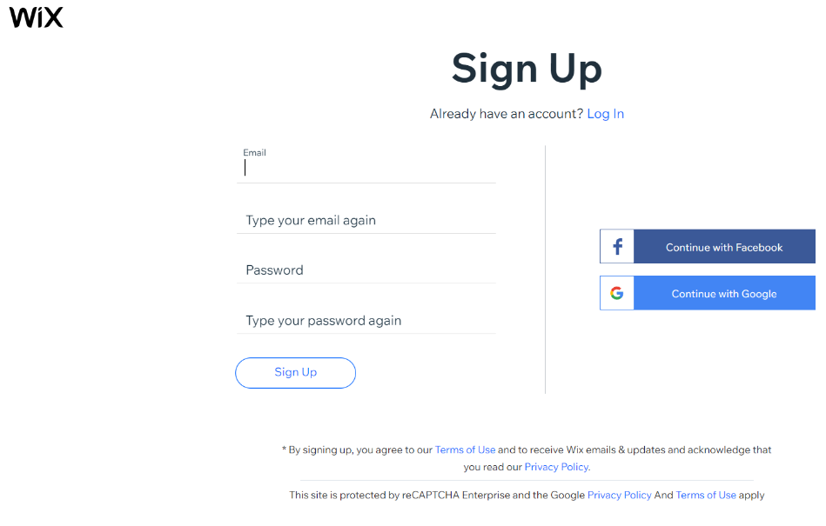

Step 4: Under Create your website with Wix Editor, click Choose a template

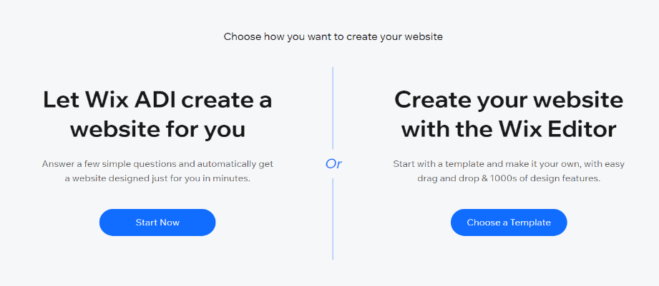

Step 5: Stop there, that’s all you need to do with Wix at this stage.

Step 6: Click on the images below to look through the website options and choose your preferred website template.

Step 7: Email memberservices@netballvic.com.au include the Subject Wix Website. In the email include your Association or League name, contact name, the email address that was used to create the Wix account and your Association or League’s preferred template (one or two) - from the options below.

Template One Template Two
